SC-300-Identity-and-Access-Administrator
Lab 01: Manage user roles
Lab scenario
Your company recently hired a new employee who will perform duties as an application administrator. You must create a new user and assign the appropriate role. His name is Chris Green. Required labs CSV files have been provided for download.
Exercise 1 - Create a new user and test their application admin rights
Task 1 - Add a new user
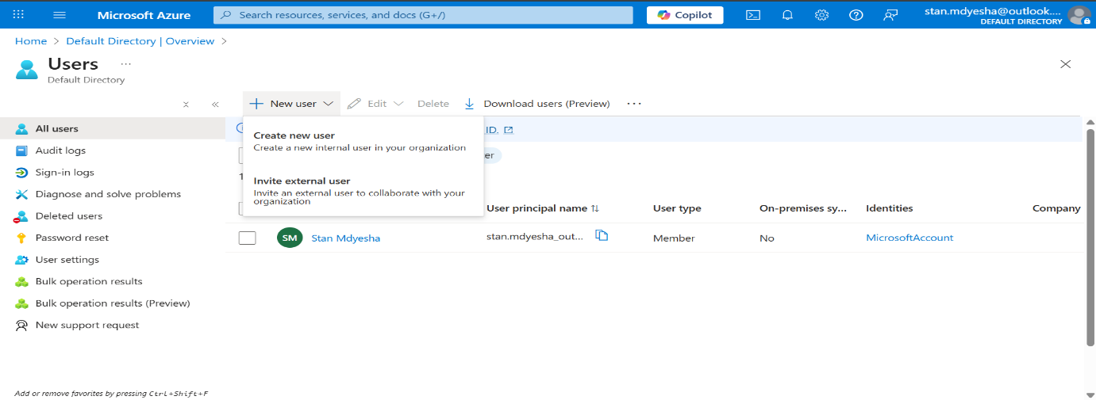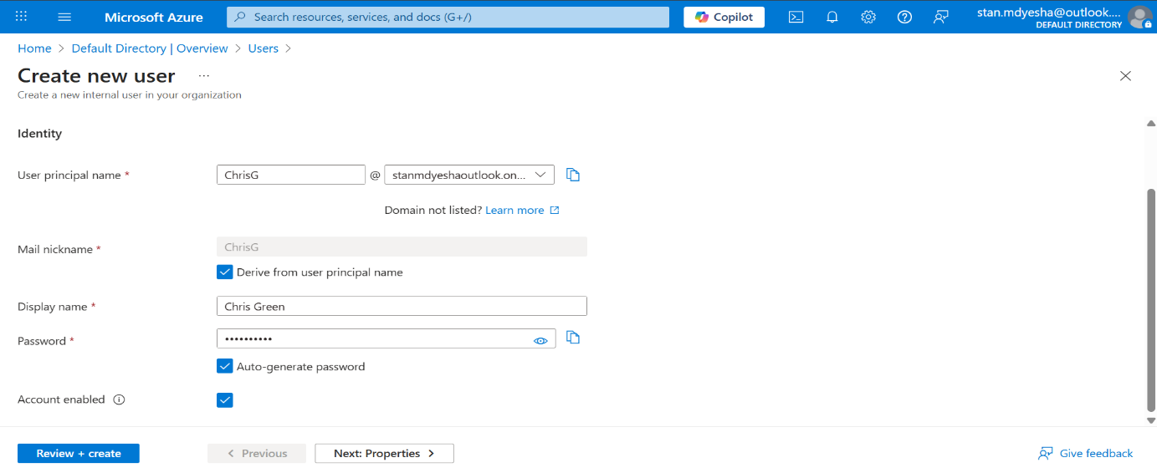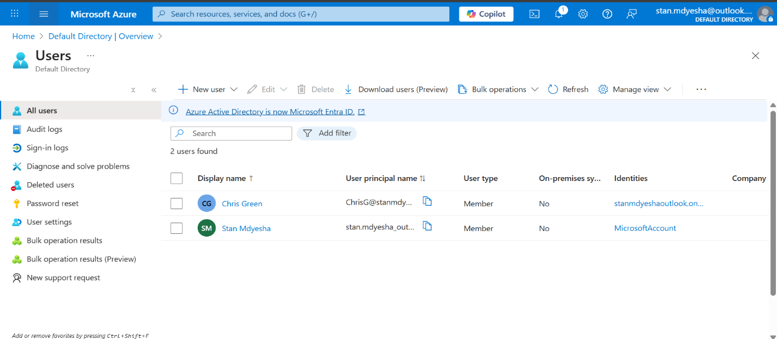
Task 2 - Login and try to create an app
I opened the Microsoft Entra admin centre https://entra.microsoft.com initially as myself then as Chris Green.
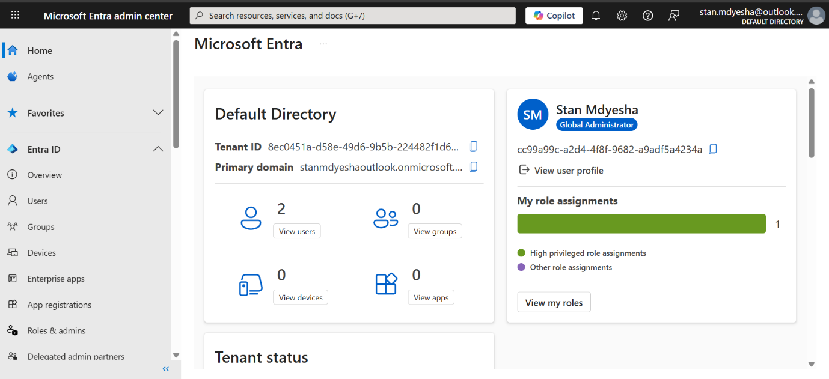
After logging in as Chris Green with the auto-generated password, I was instructed to ”update your password”.
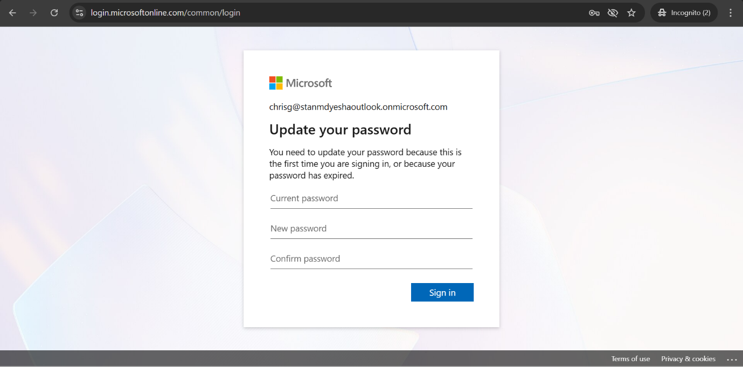

As part of Microsoft’s enhanced security features, I had to download the Microsoft Authenticator on my mobile device. Under normal, realistic circumstances, this would be done by Chris Green on his device.
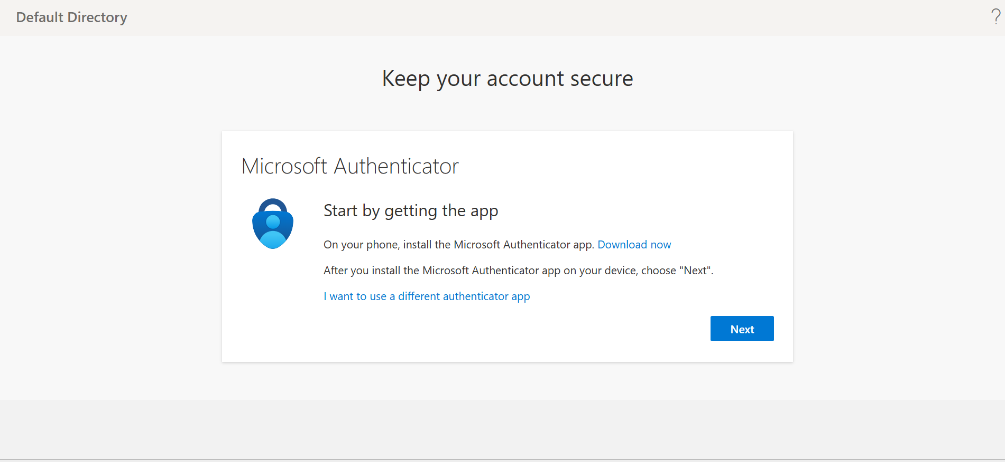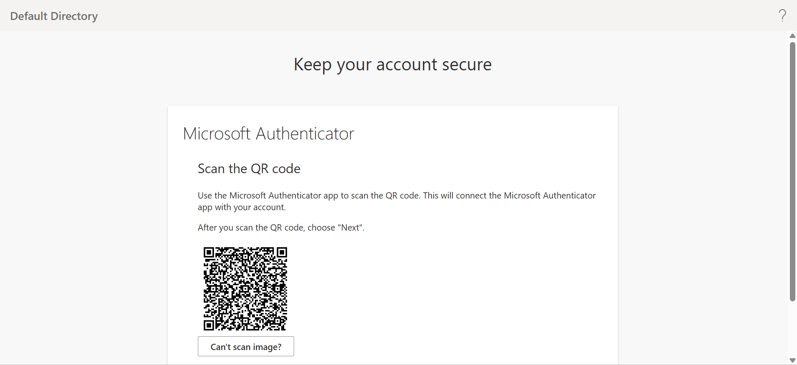
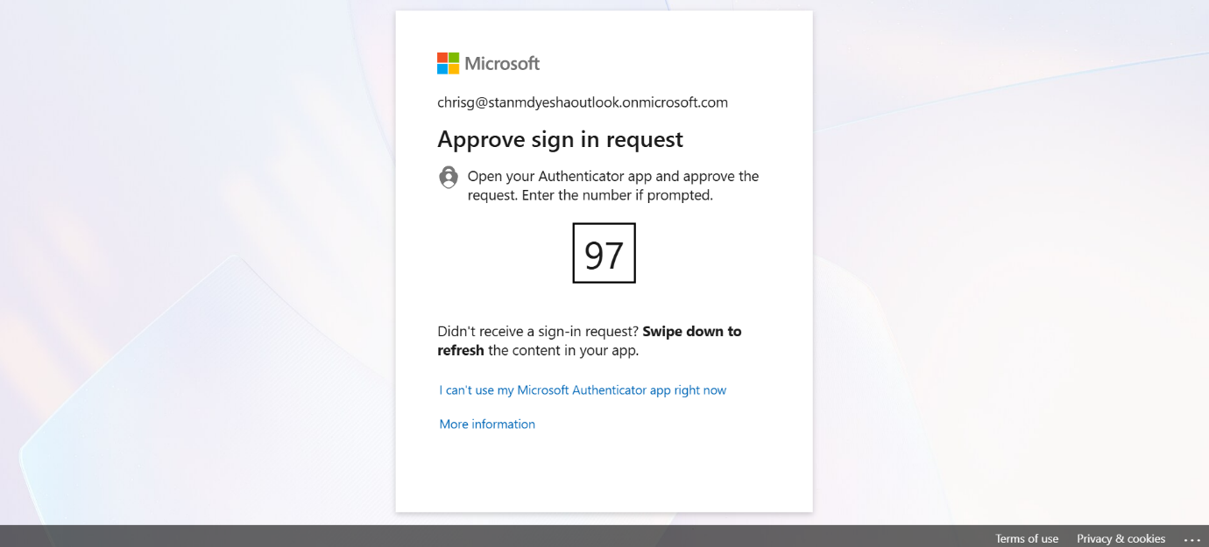
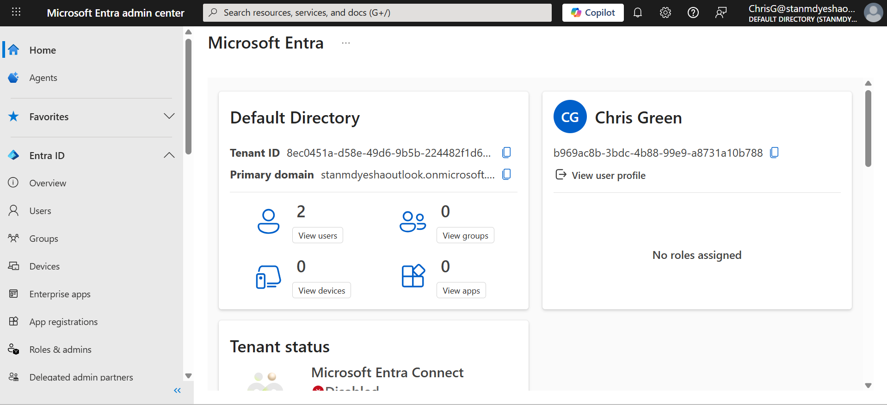
Attempting to create an app
By default, the user Chris Green had permissions to create (register) an app.
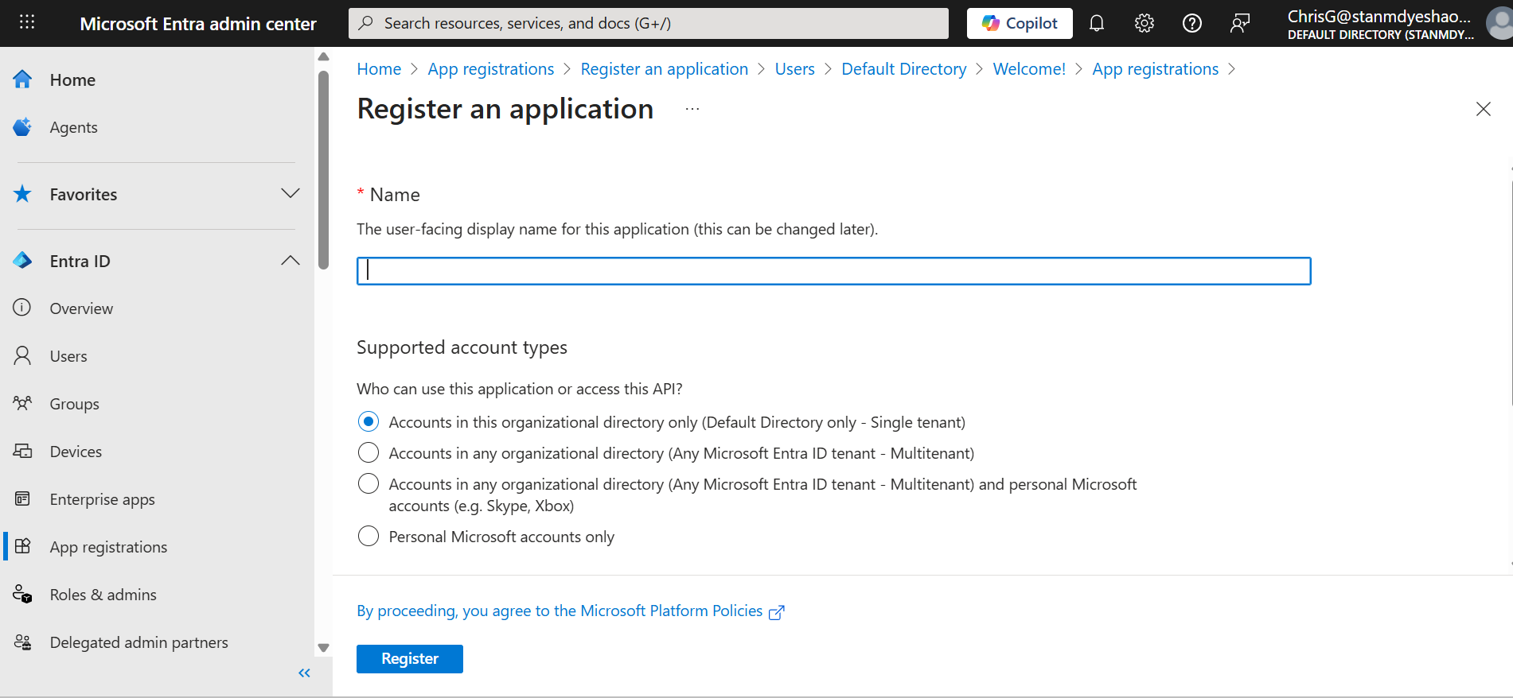
I then had to navigate to User settings and remove permissions.
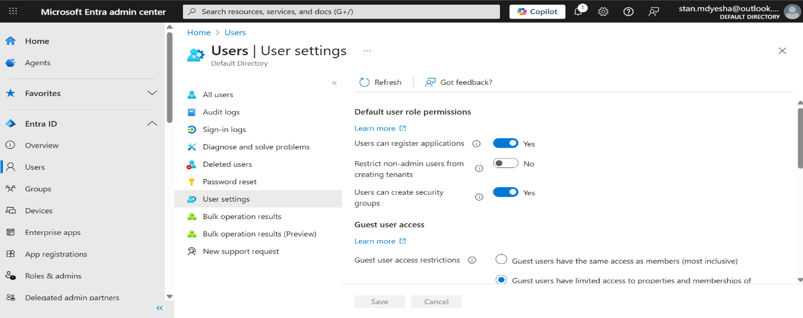
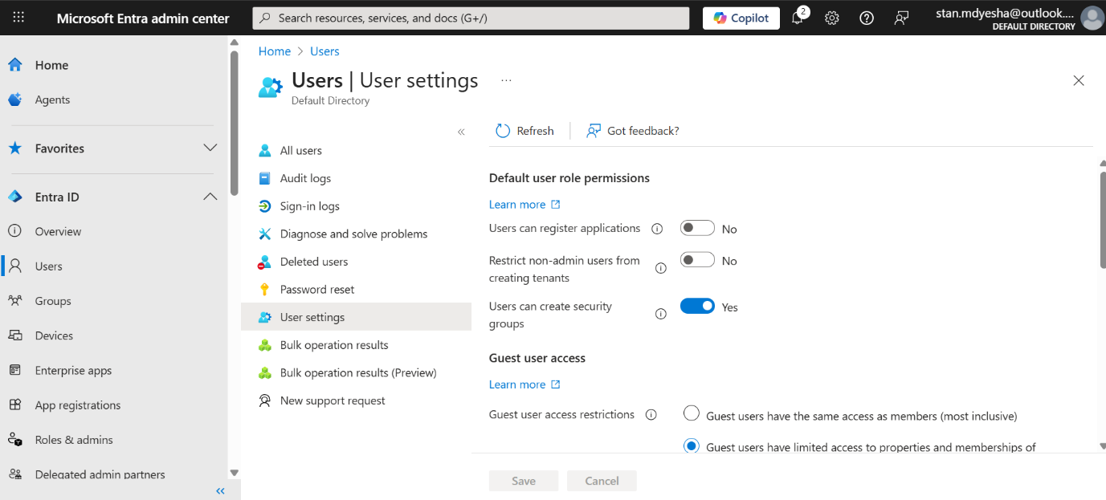
I successfully manged to remove access / permission for Chris Green to create/ register an app.
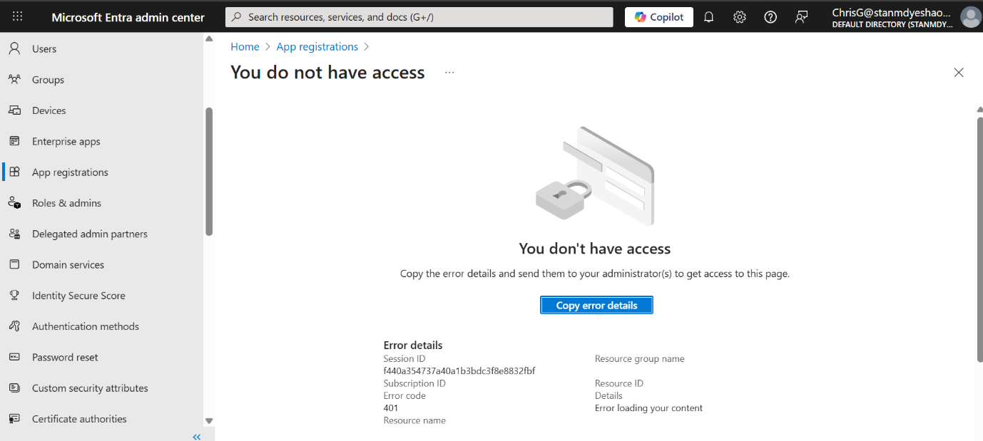

In the first part of this lab, I achieved the following:
- Create a new user and test their application admin rights
- Assign the application admin role and create an app (By default Chris Green had permissions)
- Remove the application administrator from Chris Green

Exercise 2: Bulk import of users
Using Microsoft Entra ID, you can designate limited administrators to manage identity tasks in less-privileged roles. Administrators can be assigned for such purposes as adding or changing users, assigning administrative roles, resetting user passwords, managing user licenses, and managing domain names.
Task 1 - Bulk operations for creating users with a .csv file
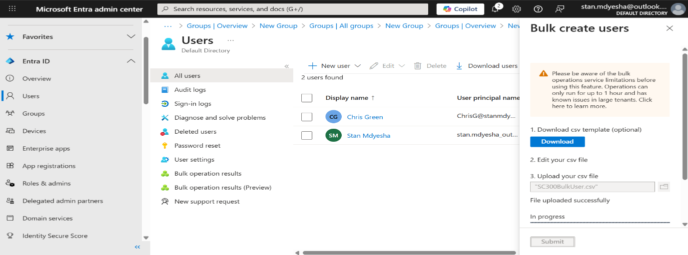
I received errors on my Bulk user downloads. The error stated that my “organization does not have Security Copilot in Entra”.
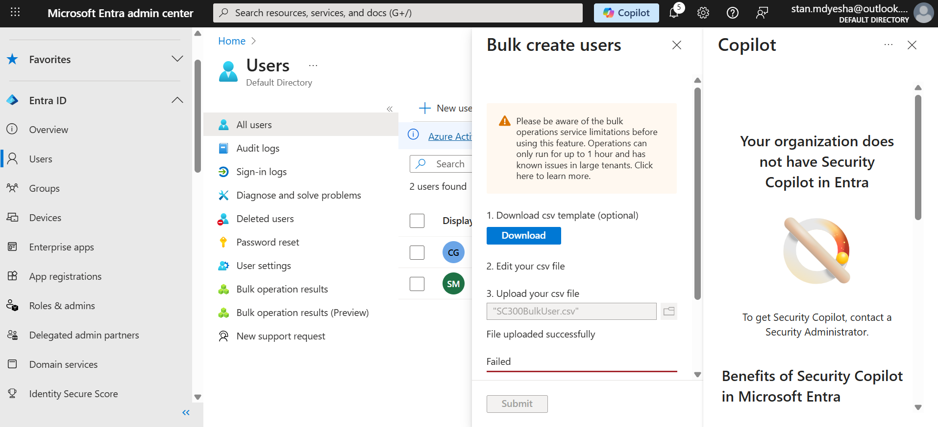
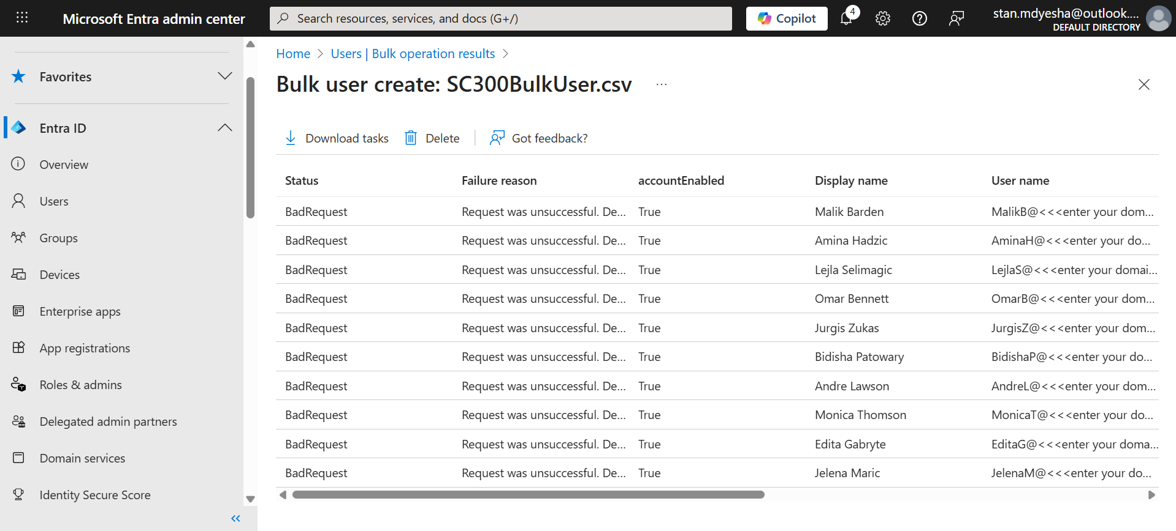
I proceeded to read documents on the Microsoft website as well as ask Copilot. After all the responses I received and double checking my formatting issues and permissions, I still couldn’t resolve the issue.
I will continue to investigate and try find a solution.
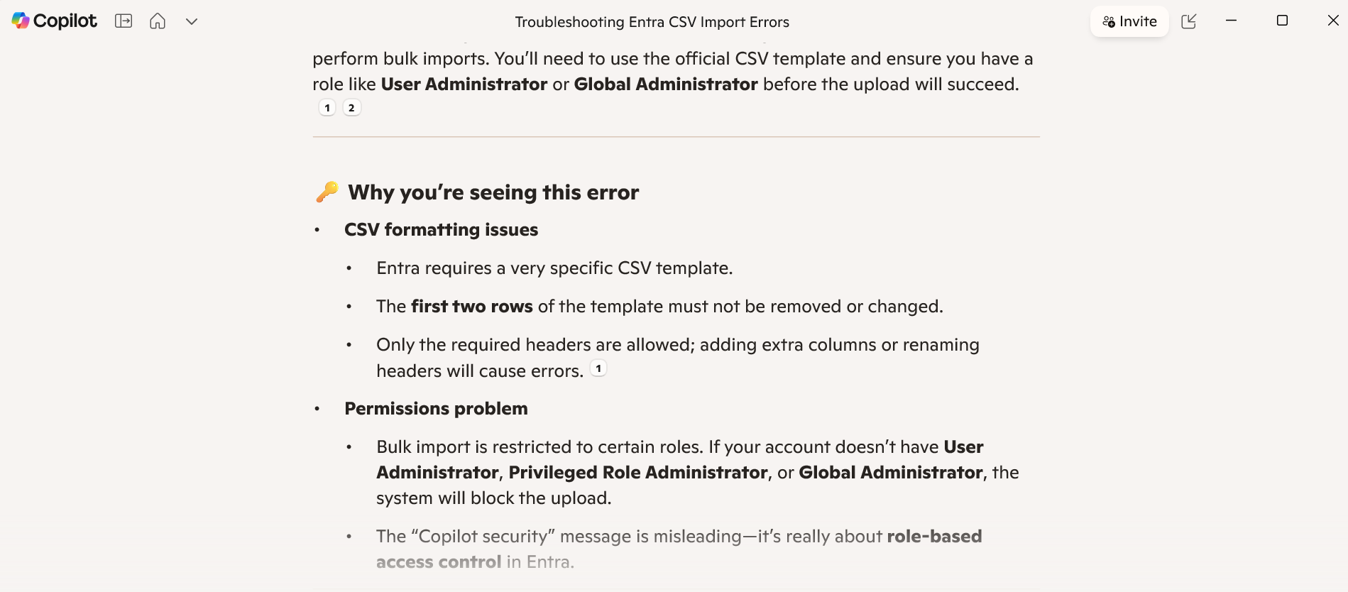
Task 2: Bulk addition of users using PowerShell
I discovered that I’d need to have PowerShell version 7.2 or higher for this lab to function.
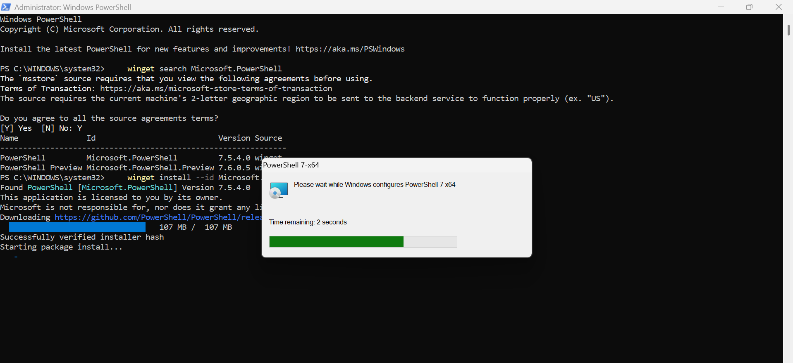
I needed to Install the Microsoft.Graph PowerShell module because i have not used it before on my current device. I ran the following command:
- Install-Module Microsoft.Graph -Scope CurrentUser -Verbose
To confirm installation, I ran:
- Get-InstalledModule Microsoft.Graph

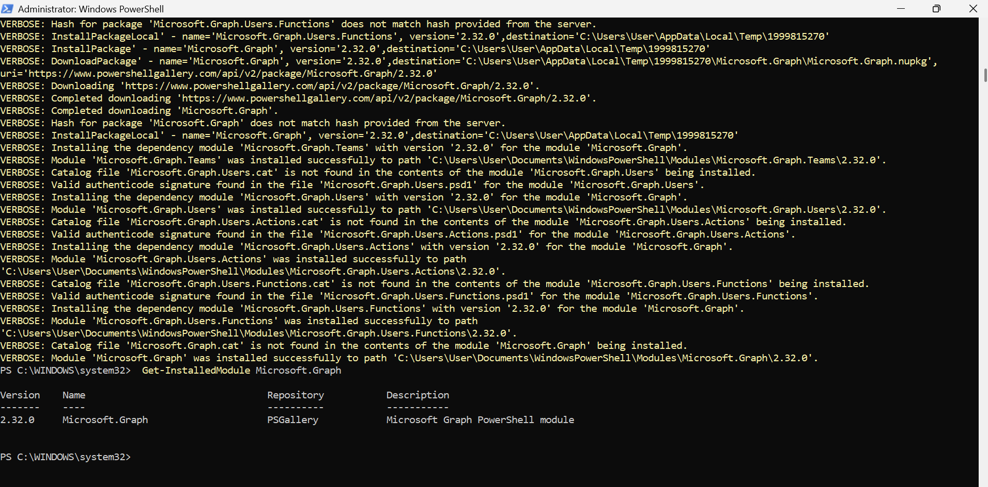
Next, I will need to login to Microsoft Graph API by running:
- Connect-MgGraph -Scopes "User.ReadWrite.All"
Unfortunetly, I could not connect to the module.
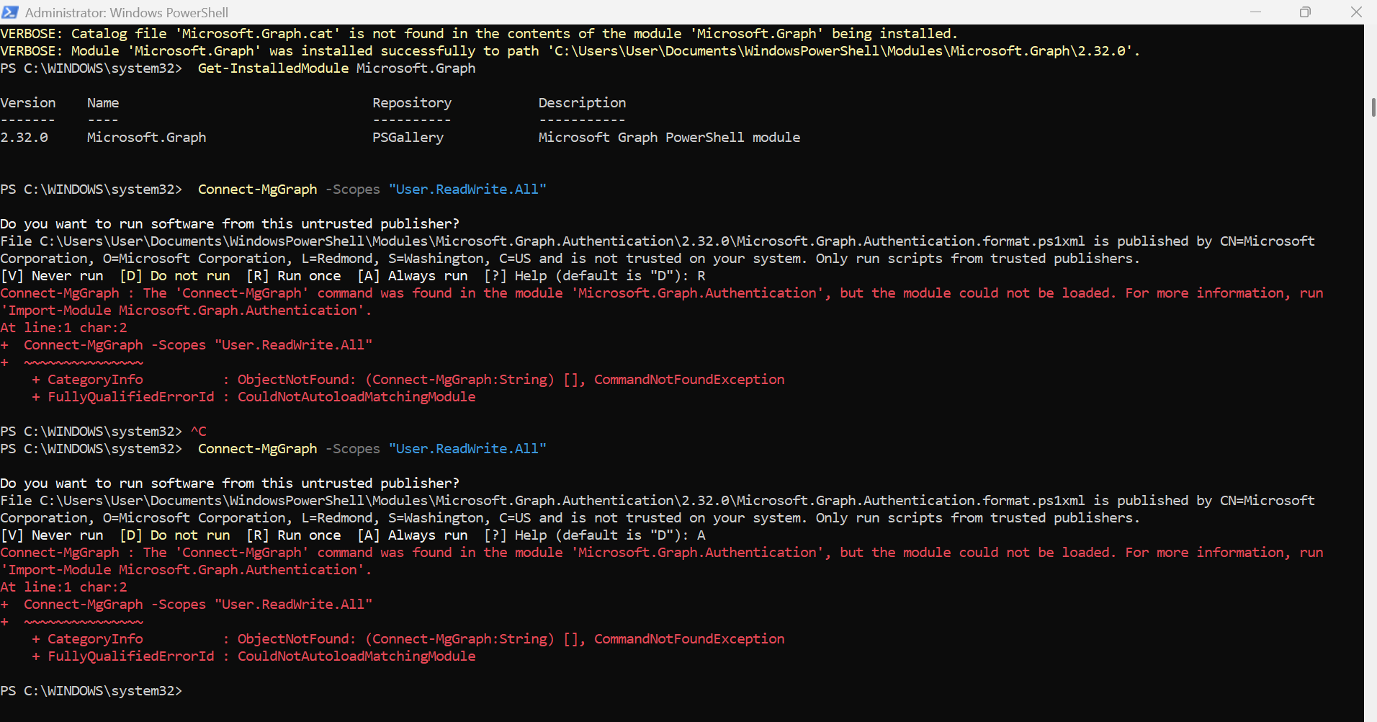
After an hour of troubleshooting, success!!!!!
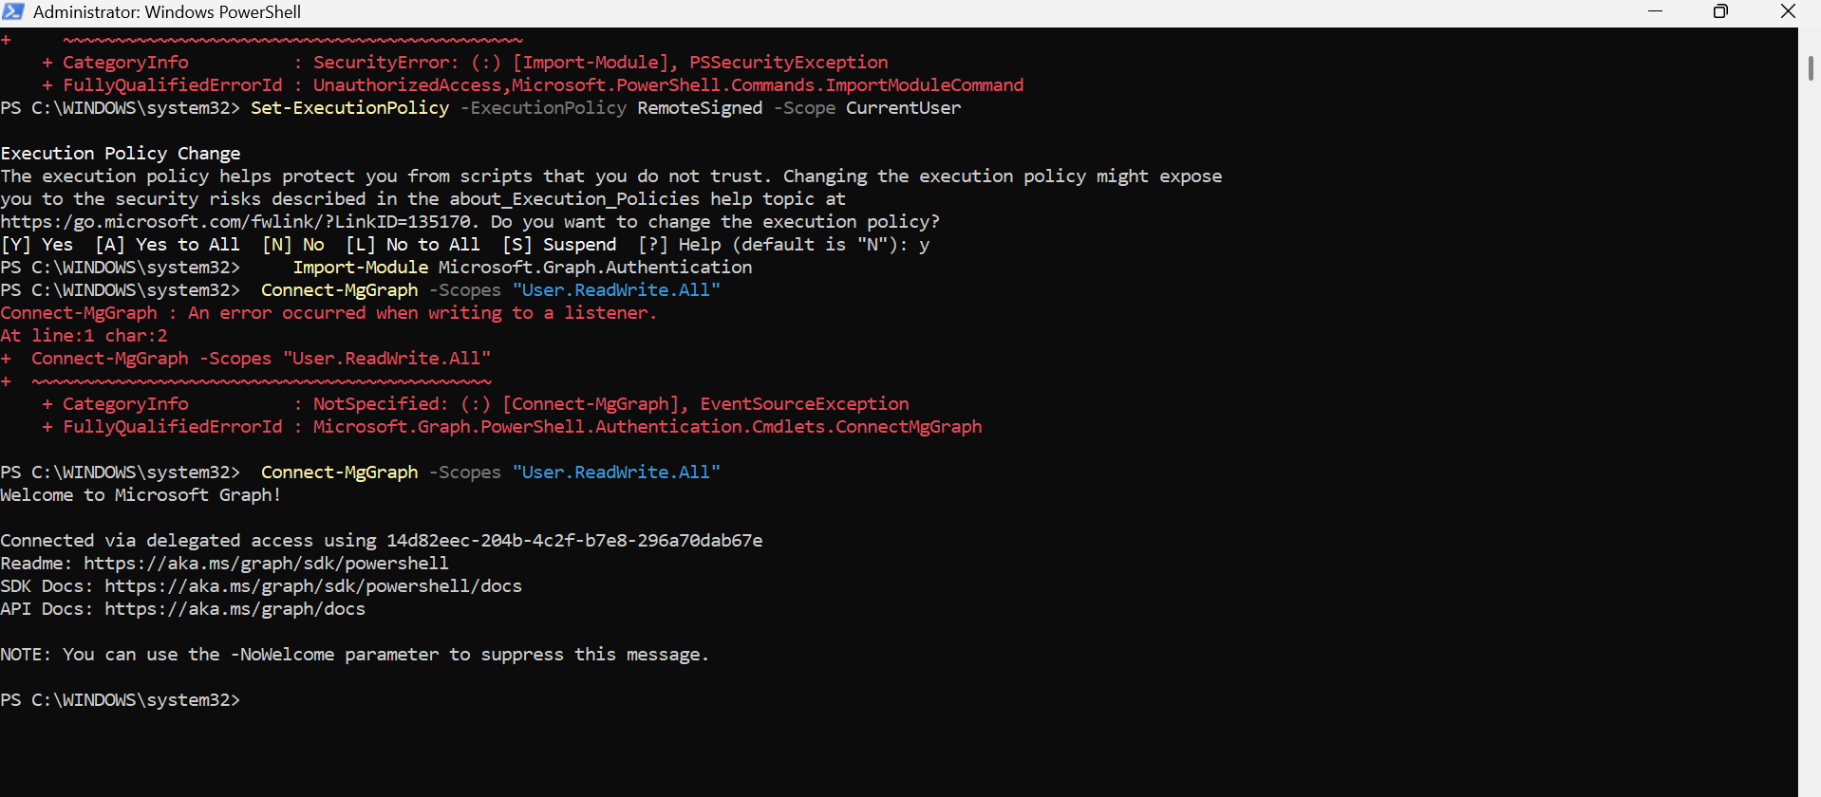
After the Microsoft sign-in page popped up and signing in, I decided to verify that I’m connected and to see existing users, I ran:
- Get-MgUser
This is where errors emerged once again. I also ran a script to assign a common temporary password to all new users. That too gave me errors. It became apparent to me that more research and consultations with more knowledgeable individuals is necessary.
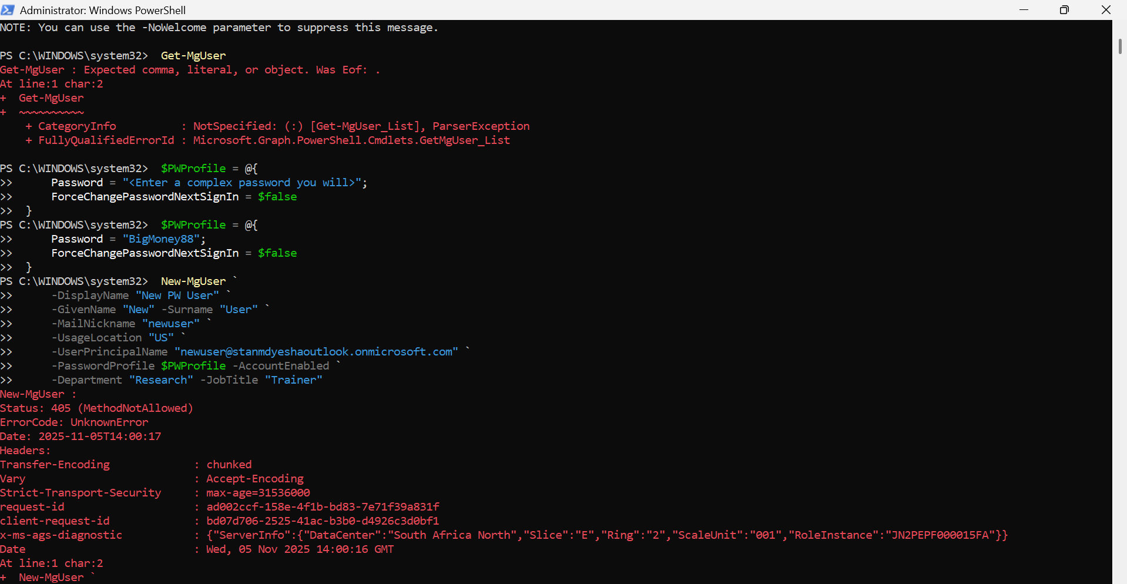

I felt it was very IMPORTANT to share this lab with all the errors and my attempts at troubleshooting them. An updated lab with resolved errors will be posted once the corrected answers and methods have been found.
THE END

